CS425 Report

# Introduction

The goal for our project it to build an online shopping system. First, we talked about our thoughts about project’s functions. Based on the discussion, we created a ER diagram and database. Then, we built a basic online shopping website to show how it would look like and what kind of function areas we need for this application. After we’ve done all of this designs, we started to realize and test those functions we designed by using python to connected with database and website to make it work. So we have several functions that can implement on our project: 1) log in ,2)sign up,3) look through products, 4)add products to cart, 5)checkout, 6)check order history. That’s how we designed our application.

# ER diagram

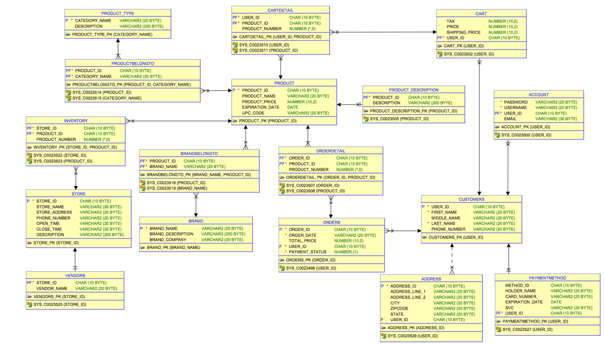

# Application

1.Main page

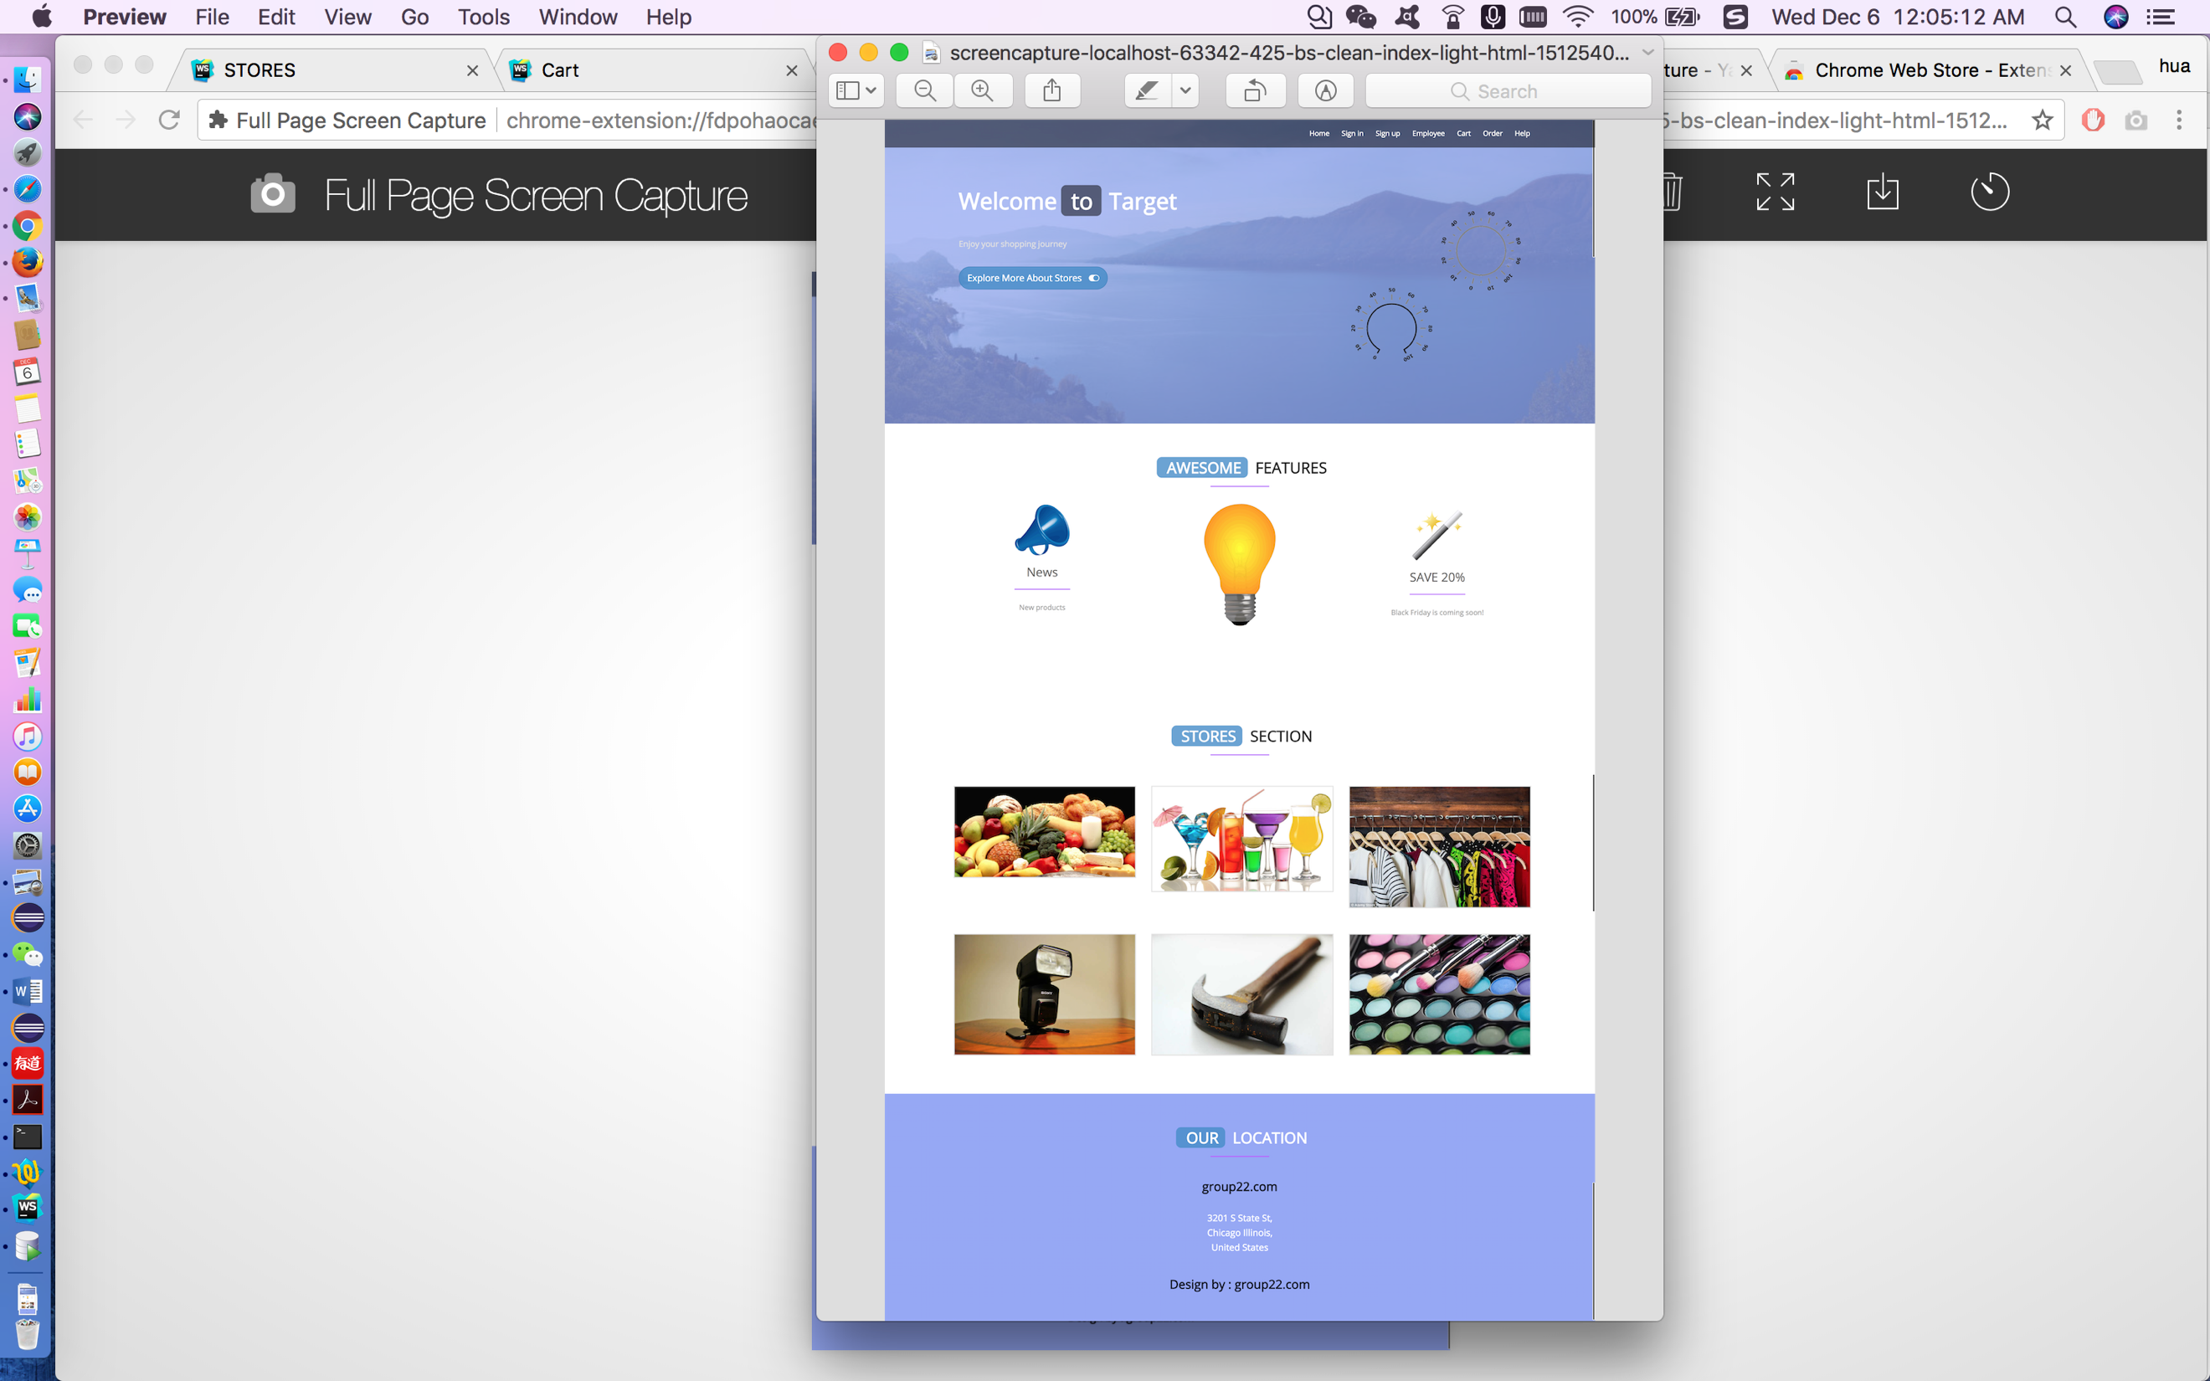

2.Sign in page

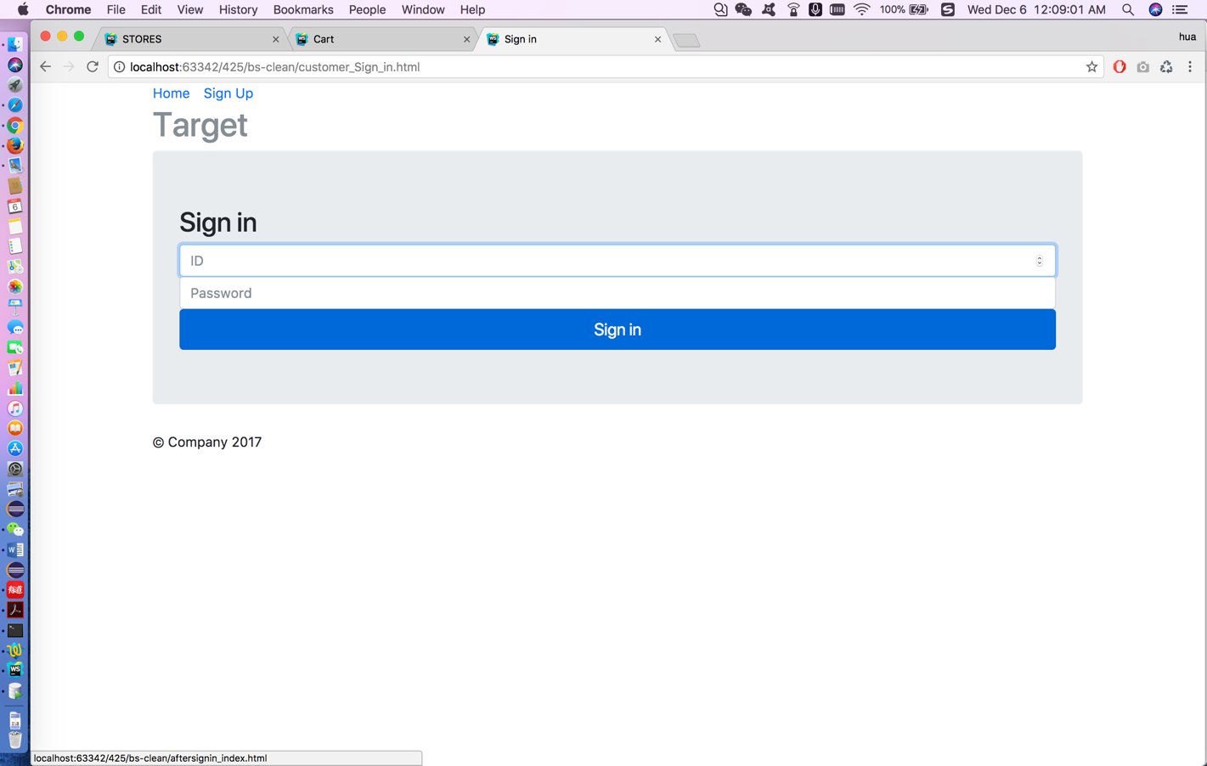

3.After signing in page

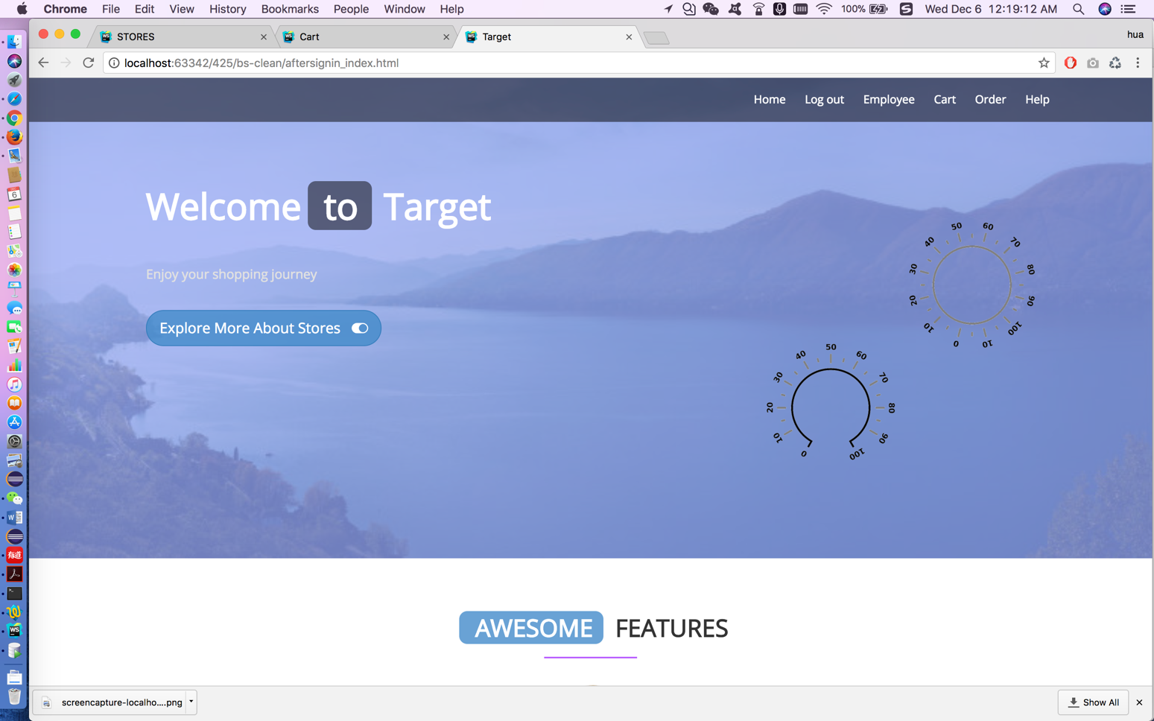

4. Sign up page

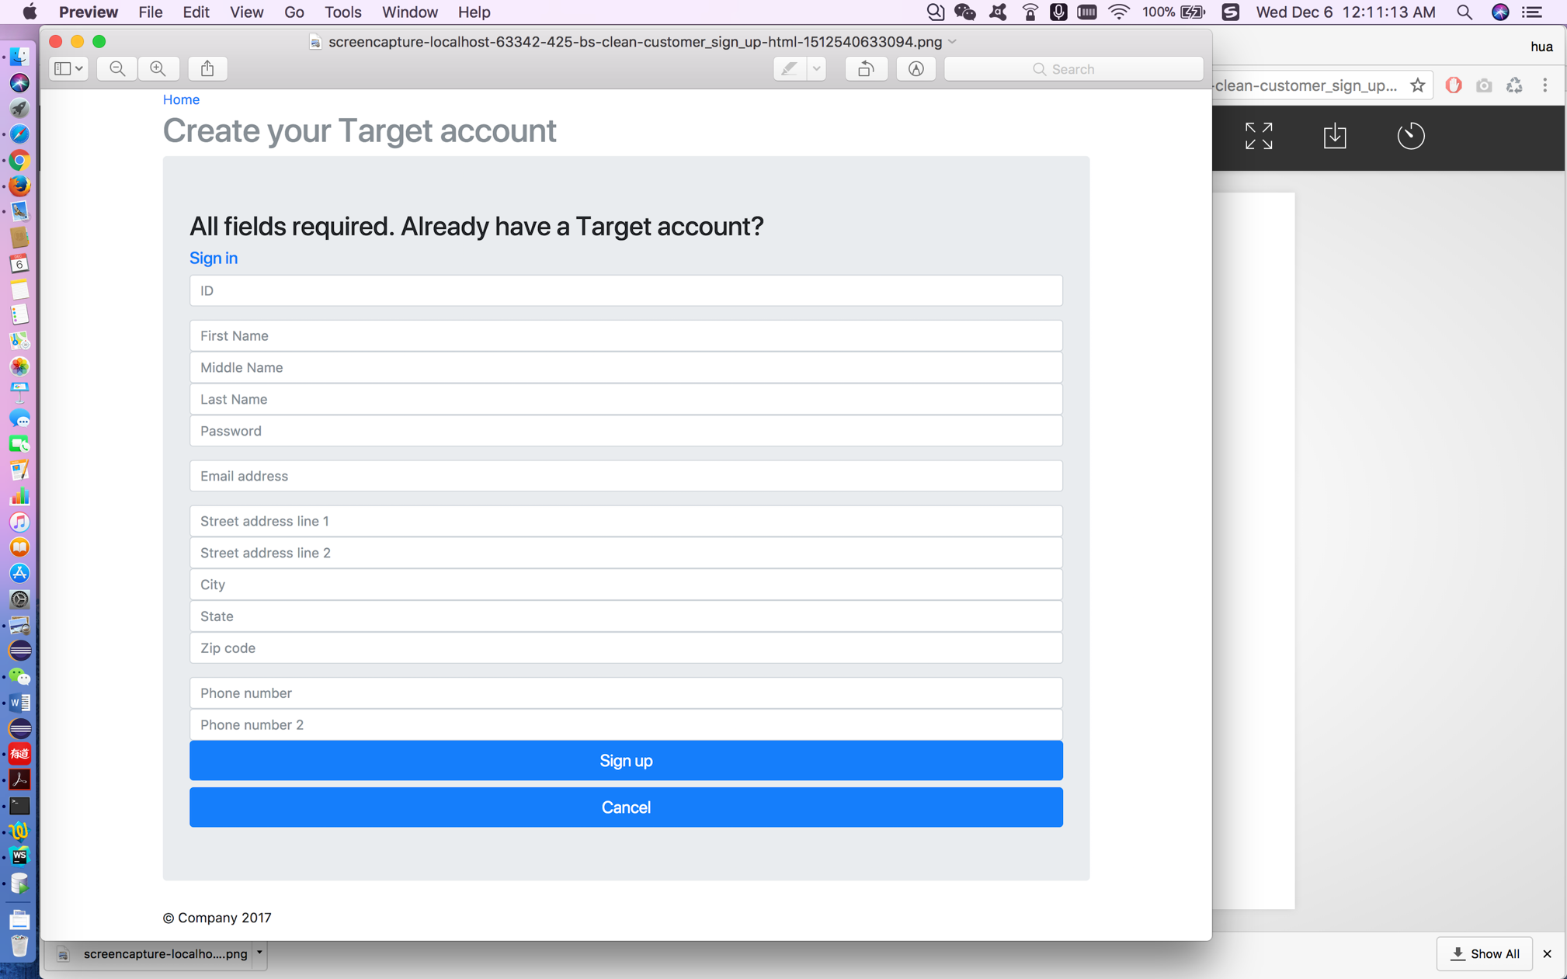

5.Product page

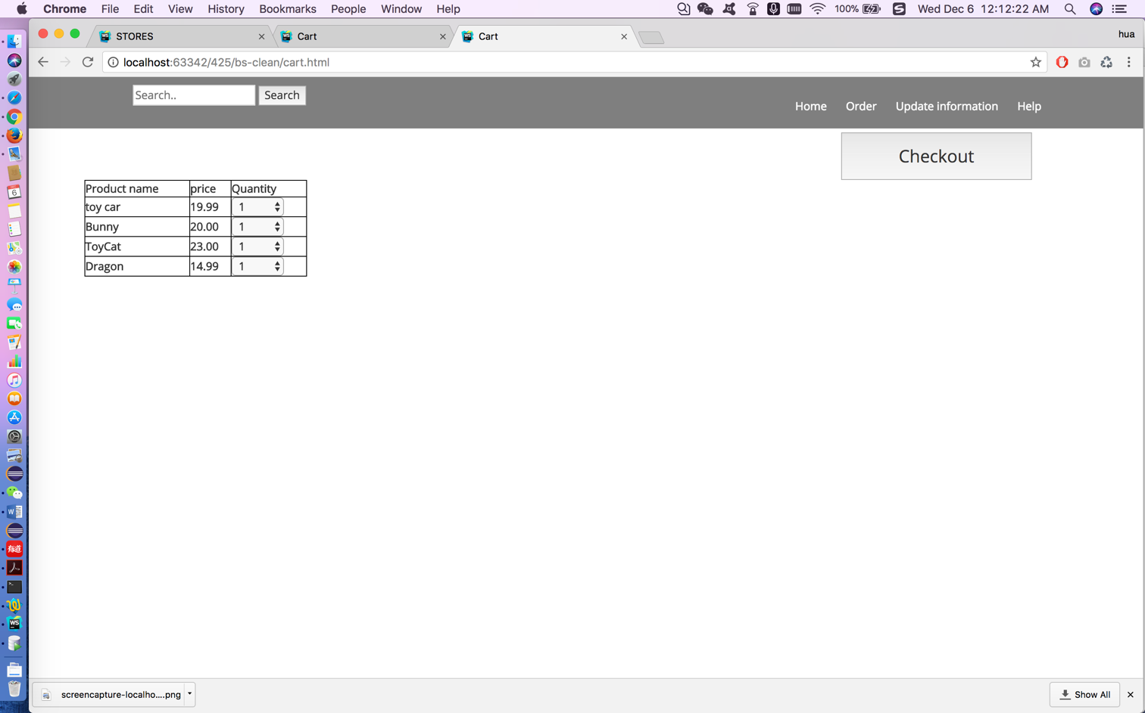

6.Cart page

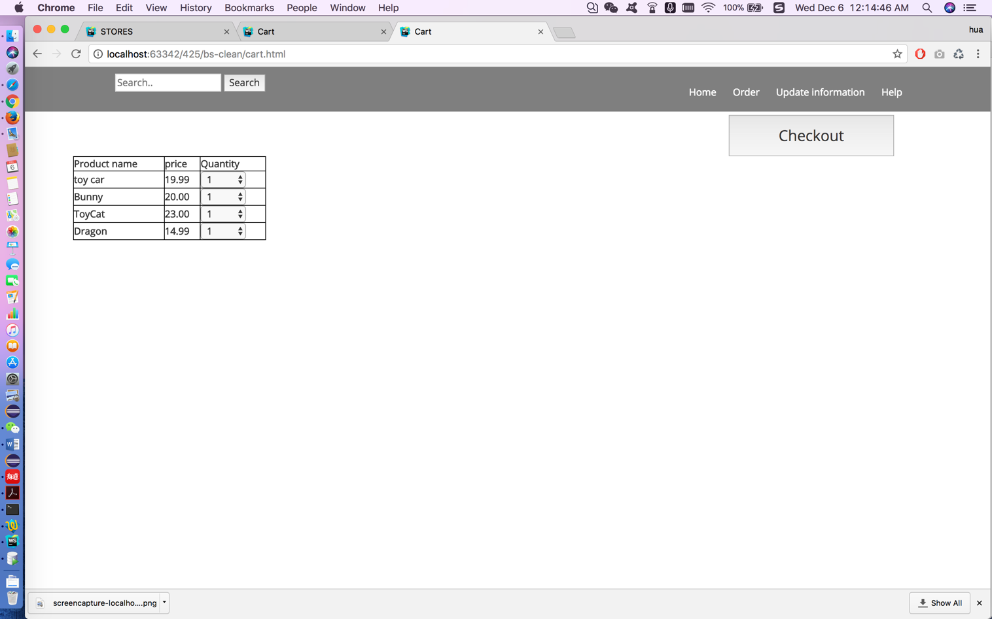

7.Order page

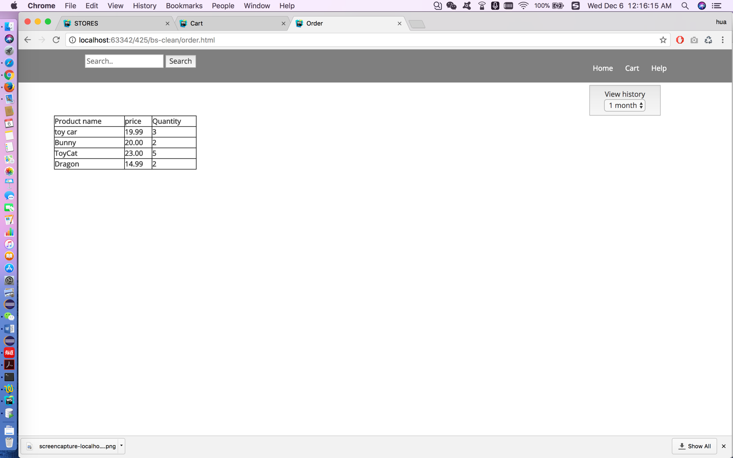

8.Help page

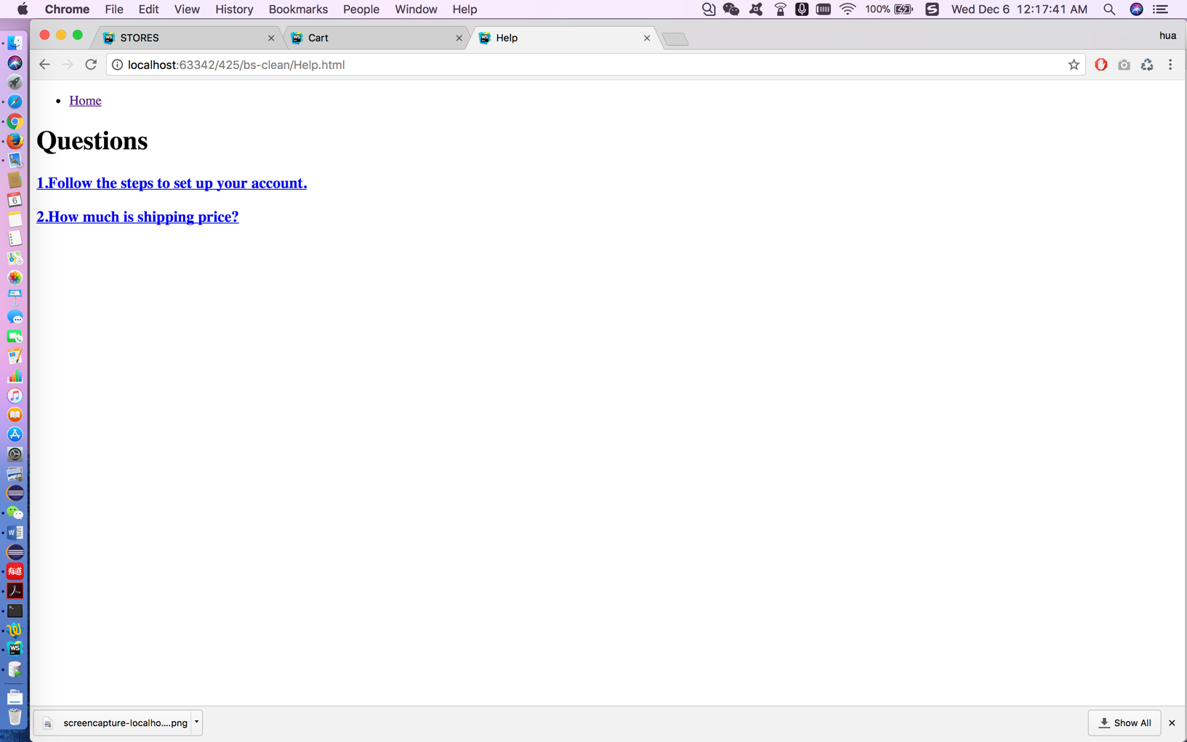

# Contributions

ER diagram—Hanzhang Liu & Hua Yang

Database design—Hanzhang Liu & Hua Yang & Yohann Flrd

SQL script and queries—Hanzhang Li

Website design—Hua Yang

Code design—Yohann Flrd

# Description

# Source code()

# SQL script()